CCM2 Warm - Ups
Unit 2: Quadratic Functions

- Write an equivalent expression for each of the problems below:
  - (x + 2)(x + 4)
  - (x – 5)(x + 8)
  - (x - 9)²
  - (x + 10)²
  - (x – 8)(x + 8)

- Using the equation expression 5 + 30x – 16x²:
  - Explain what each part of the equation represents.
  - Write a story that relates to the function.
  - What is the maximum? When does it occur? What does this mean in the context of your story?
  - Solve for the zeros of the expression and explain what they mean in the context of your story.

- Factor to solve the following:
  - x² – 5x + 50 = 0
  - x² + 3x = 10
  - 2x² + 7x = -3

- Factor to solve the following:
  - x² + 2x -35 = 0
  - 2x² + x = 3
  - 3x² + 10x = 8

- Factor to solve the equation x² – 7x + 10 = 0. Explain what the solutions tell you about the graph. Using what you know about the quadratic function, draw a rough sketch.

- For the following two equations, find the zeros, find the maximum/minimum, then sketch the graphs.
  - x² – x – 20 = 0
  - x² + 8x + 15 = 0

- Jason and Jim jumped off of a cliff into the ocean in Acapulco while vacationing Jason’s height as a function of time could be modeled by the function h(t) = − 16t +16 t + 480, while Jim’s height could be modeled by h(t) = -16t² + 12t + 480 where t is the time in seconds and h is the height in feet. Whose jump was higher and by how much?

- Jenna is trying to invest money into the stock exchange. After some research she has narrowed it down to two companies. Company A shows a portfolio value of v(t) = 800 – 28t +.25t², and Company B shows a portfolio value of v(t) = 700 - 65t + .3t², where v is the value of the portfolio in hundreds of dollars and t is the time in months. Which company will allow her the peace of mind of having the higher value, even if the stock prices drop to their lowest?

- Solve each of the quadratic functions by graphing and algebraic reasoning

  - x² – 3 = 0
  - x² +5x – 8= 0
  - Explain why having alternative methods of solving is important.

- Using the quadratic formula find the zeros of the following:
  - x² – 9x + 12 = 0
  - x² + 4x – 16 = 0
  - 2x² + 8x – 13 = 0

- Using the discriminant determine how many solutions each equation will have:
  - x² + 4x + 5 = 0
  - x² – 2x + 1 = 0
  - 2x² – 3x – 10 = 0

- Given the following functions, explain the transformation from the identity function y = x²
  - y = (x+3)² – 7
  - y = 5x² + 12
  - y = ½(x – 2)² + 4

- A local school determines that the profit of putting on a talent show is affected by the number of tickets sold. They have determined the show will cost $500 and their income is represented by the function I(t) = t(200 – 2t) where t is the ticket price.
  - Write the function that represents profit. (Hint: Profit = Income – Cost)
  - Graph both the Profit and Income graphs on the same axes.
  - Determine the break even points.
  - Using different colored pencils, show where the Cost will be greater than the Income and where the Income will be greater than the cost.
  - What ticket price range should the school use if they want to make a profit?

- Graph the following quadratic inequalities:
  - y ≤ x² – 3x – 28
  - y ≥ x² + 4x - 12
  - y < x² + 6
CCM2 Warm – Ups – Answer Key
Unit 2: Quadratic Functions

- Write an equivalent expression for each of the problems below:
  - (x + 2)(x + 4) = x² + 6x + 8
  - (x – 5)(x + 8) = x² + 3x - 40
  - (x - 9)² = x² – 18x +81
  - (x + 10)² = x² + 20x + 100
  - (x – 8)(x + 8) = x² - 64

- Using the equation expression 5 + 30x – 16x²:
  - Explain what each part of the equation represents. 5- initial height, 30 – velocity, -16t² - gravity
  - Write a story that relates to the function. Answers may vary: Joe releases a baseball from 5 feet in the air at a rate of 30 feet per second.
  - What is the maximum? When does it occur? What does this mean in the context of your story? Max = 19.2 ft. occurs at .94 seconds, Answers may vary: when the ball was at its highest point
  - Solve for the zeros of the expression and explain what they mean in the context of your story. x = -.15 and x = 2, The negative does not matter since x represents time and time cannot be negative, the x=2 represents how long the ball was in the air or when it hit the ground.

- Factor to solve the following:
  - x² – 15x + 50 = 0 x = 10 x = 5
  - x² + 3x = 10 x = -5 x = 2
  - 2x² + 7x = -3 x = -1/2 x = -3

- Factor to solve the following:
  - x² + 2x -35 = 0 x = 5 x = -7
  - 2x² + x = 3 x = 1 x = -3/2
  - 3x² + 10x = 8 x= 2/3 x = -4

- Factor to solve the equation x² – 7x + 10 = 0. Explain what the solutions tell you about the graph. Using what you know about the quadratic function, draw a rough sketch. x intercepts at x = 2 and x = 5, has a minimum at (3, -2) , y intercept at (0,10) and will open up.

- For the following two equations, find the zeros, find the maximum/minimum, and then sketch the graphs.
  - x² +2 x – 35 = 0 zeros at x = 5 and x = -7, a minimum at (-1, -36), y intercept at (0,-35)
  - -x² - 8x - 15 = 0 zeros at x = -3 and x = -5, a maximum at (-4,1) y intercept at (0,-15)
- Jason and Jim jumped off of a cliff into the ocean in Acapulco while vacationing Jason’s height as a function of time could be modeled by the function h(t) = − 16t +16 t + 480, while Jim’s height could be modeled by h(t) = -16t² + 10t + 480 where t is the time in seconds and h is the height in feet. Whose jump was higher and by how much?
Jason’s highest point was 484
Jim’s highest point was 481.6
Jason’s jump was higher by about 2.4 feet

- Jenna is trying to invest money into the stock exchange. After some research she has narrowed it down to two companies. Company A shows a portfolio value of v(t) = 800 – 28t +.25t², and Company B shows a portfolio value of v(t) = 700 - 30t + .3t², where v is the value of the portfolio in hundreds of dollars and t is the time in months. Which company will allow her the peace of mind of having the higher value, even if the stock prices drop to their lowest?
Company A’s lowest value is $16
Company B’s lowest value is -$50
She should use Company A, since Company B will cause her to lose much more money.

- Solve each of the quadratic functions by graphing and algebraic reasoning

- x² – 3 = 0 x = $\sqrt{3}, -\sqrt{3}$
- x² +5x – 8= 0 x = 1.27, x = -6.27
- Explain why having alternative methods of solving is important.
Sometimes we can’t solve equations algebraically by factoring, but we can visually inspect that it crosses the x-axis twice, so it still has two real roots

- Using the quadratic formula find the zeros of the following:
  - x² – 9x + 14 x = 7 and x = 2
  - x² + 4x – 16 x = -2 + 2√5 and x = -2 - 2√5
  - 2x² + 8x + 13 no real solutions

- Using the discriminant determine how many solutions each equation will have:
  - x² + 4x + 5 = 0 no real solutions
  - x² – 2x + 1 = 0 1 real solution
  - 2x² – 3x – 10 = 0 2 real solutions

- Given the following functions, explain the transformation from the identity function y = x²
  - y = (x+3)² – 7 shift left 2 and down 7
  - y = 5x² + 12 narrower and shift up 12
  - y = ½(x – 2)² + 4 wider, shift right 2 and up 4

- A local concert venue determines that the profit of putting on a battle of the bands show is affected by the number of tickets sold. They have determined the cost is shown by the function C(t) = 500 + 25x and their income is represented by the function I(t) = t(150 – t) where t is the ticket price.
  - Write the function that represents profit. P(t) = -t² +125t - 500
  - Graph both the Profit and Income graphs on the same axes.
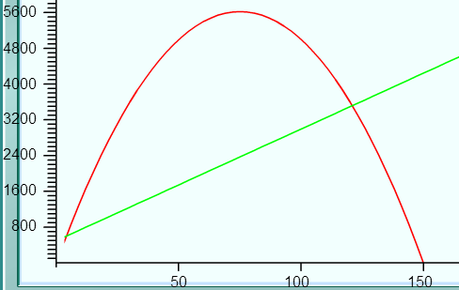
  - Determine the break even points and explain what this means in the context of the problem. (120.68,3521.58) and (4.14, 603.42) When the ticket prices is 120.68 or 4.14 the income and the cost will be equal, resulting a profit of $0.
  - Using different colored pencils, show where the Cost will be greater than the Income and where the Income will be greater than the cost.
Cost is greater when 4.14 > t <120.68 Income is greater when 4.14 < t < 120.68
  - What ticket price should they use if they want to make the highest profit? Charging $75 will give an income of $5625 and a profit of $3250

- Graph the following quadratic inequalities:
  - y ≤ x² – 3x – 28
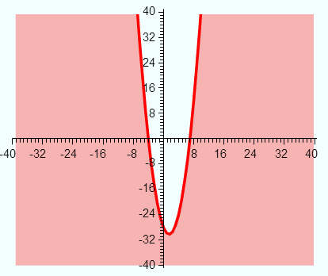
  - y ≥ x² + 4x - 12
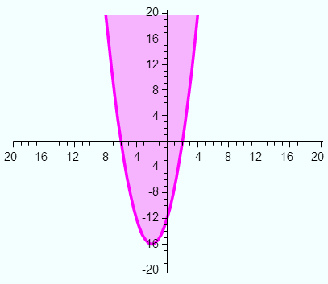
  - y > x² + 6
