### 

Our Vision: Mary E. Phillips will be the highest performing school in Wake County.

Fall 2013

**Common Core Math 2**

**Course Description**: Common Core Math 2 provides learners with an opportunity to review Common Core 1 and geometry skills while obtaining a deeper understanding of Algebra 2 through solving equations, inequalities and word problems. Students will solve relevant and authentic problems using manipulative and appropriate technology.

.

Grading Policy

**Tests 20%**

**Quizzes 30%**

**Classwork** **20%**

**Homework 10%**

**Projects 20%**

**The final exam counts **20%** of the student's grade.



**Mary Phillips Honor Code** is the following statement : ***“As the undersigned, I acknowledge that I am aware of the Honor Code at Mary Phillips High School and that I will not copy or allow copying of my hard work. I have adhered to the Honor Code and have neither given nor received inappropriate or unfair help on my assignments.”***

**Instructor:**

Ms. B. Thomas

**Email:**

[bthomas@wcpss.net](mailto:bthomas@wcpss.net)

Please allow me 48 hours to respond to your concerns.

**Website:**

http://phillips.wcpss.net

**School Phone:**

**919-856-7710**

**Grades online:**

<https://wwww.//wcpss.net/parents/homebase>

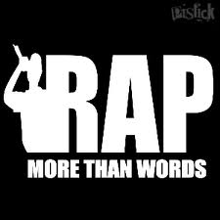

Announcements

* Assignments will be provides on my Weebly page at http://www.bthomas.weeby.com.
* **Tutoring**

Will be scheduled according to seminars

* **Meet-the-Teacher Night:**

August 21, 2013

Supply List

* Spiral Notebook
* Dividers with pocket

1. Warm-ups

2. Notes

3. Projects

4. Quizzes

5. Miscellaneous

* Notebook paper
* Note cards
* Pencils!!
* **Graphing calculator**

**TI-83+,**



Tardy Policy

You must be in the classroom

BEFORE the bell rings.

**1st offense:** Teacher warning

**2nd offense:** Parent contact

**3rd offense:** Parent contact

& administrative referral.

"I hear and I forget.

I see and I remember.

I do and I understand."

~Chinese Proverb

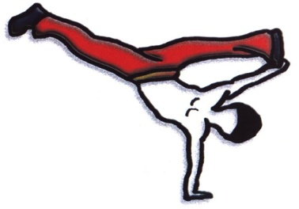

**Mary E. Phillips Mission**

Mary E. Phillips will significantly increase achievement for all students regardless of back-ground or societal factors by developing a caring respectful

Environment and creating a culture of excellence through a rigorous and relevant 21st century curriculum that fosters relationships and produces responsible global citizens.

**What you can expect of me**

* Respect for you.
* Enthusiastic & caring.
* Prepared.
* Positive attitude.
* Timely grading and

posting of grades.

* Available for help.

**Class Expectations**

* Be respectful.
* Be prepared.
* Be prompt.
* Be positive.
* Be responsible.
* Follow all school rules and dress code.

**Absences**

Work assigned prior to the

absence is due upon return.

In case of illness, students

have two days for every

day absent to turn in the

assignments/ make up tests.

**Classwork**

CLASSWORK is due at the END of class.

Group work requires leaders and good citizens.

Problem solving and creativity skills are key.

Take good notes and study materials daily.

Look at calendar on Weebly for activities, tests and quizzes.

Keep up to date on my weeby site..

**Mary Phillips is Going Green!!**

There is no book for this course. Students will receive most documents for each unit from the teacher, packets. These materials need to be kept in their binder. The documents provided by the teacher will help ensure their success in Algebra 2! Additional materials and resources will be available on the designated sites. Students can print these at home, in the Phillips library, or at the public library. I will show students how to retrieve the documents in class on the first day. If you have any questions please let me know.

**Helpful Websites:**

WCPSS Success Series Videos Geometry topics  
[http://www.wcpss.net/success-series/hs-Algebra 2](http://www.wcpss.net/success-series/hs-Algebra%202)

Pearson

http://

www: pearson.com

You Tube tutorial

Novanet

[www.novanet.com](http://www.novanet.com)

**Parents**

**Progress reports will be issued every two weeks. Please sign and return to me.**

**Please do not hesitate to come and receive help throughout the semester. Don’t get behind ~ I will gladly assist you at any point!**

The following topics will be covered:

Review of Geometry

One Variable Statistics

Linear equations

Absolute Value

Systems of equations & inequalities

Graphing quadratics functions & factoring

Solving quadratic functions

Polynomials & Polynomial functions

Exponential and logarithmic

Rational Functions

Radical & inverse functions

Trigonometric function